

**UNIVERSITY OF ASIA PACIFIC**

**DEPARTMENT OF COMPUTER SCIENCE & ENGINEERING(CSE)**

**Course Title:** Database Systems Lab

**Course Code:** CSE 212

**Project Name :**

**Date of Performance:**

**Date of Submission:**

**Submitted By, Submitted To,**

Name ID **Nadeem Ahmed**

**(Assistant Professor)**

**Shahriar Alam Shimul 22201227**

**Salman Nur Ramim 22201239**

**M Sakib Rahman 22201240**

**Sadman Sarwar Nabid 22201242**

**H.M. Tahsin Sheikh 22201243**

**Sec: E**

**Year-Semester: 2nd Year-2nd Semester**

**Table of contents**

***AGRITULTURE YIELD PREDICTION***

**1.Topic**

**1.Agriculture Yield Production Management System (AYPMS)** is a technology-driven solution designed to enhance farming efficiency and productivity. It integrates advanced data management techniques with modern agricultural practices to monitor, analyze, and optimize crop yield. AYPMS leverages a combination of Geographic Information Systems (GIS), Internet of Things (IoT) devices, and data analytics to provide real-time insights into soil health, weather conditions, crop growth, and pest infestation. 2.It is essential for sustainable agricultural practices and effective resource allocation. The need for precise yield predictions has grown due to factors like climate change, resource scarcity, and the growing global population. By integrating various data sources, the system helps optimize crop management and forecasting, thereby improving agricultural productivity, reducing costs, and ensuring food security.

**2.Description**

**An agriculture yield prediction management system is a comprehensive database or repository that collects, organizes, and manages various types of agricultural data to support the efficient and accurate forecasting of crop yields. This type of system is designed to handle the vast and complex relationships between different types of data, which can include:**

**1.** **Information on soil quality and composition:** Detailed data about soil nutrients, pH levels, and other factors that impact crop growth.

**2.** **Weather and climate data:** Historical and real-time data about rainfall, temperature, humidity, and other climatic conditions essential for predicting agricultural yields.

**3.** **Crop and seed data:** Information about different crops, seed varieties, growth patterns, and optimal planting and harvesting times.

**4. Fertilizer and pesticide usage**: Data on the types and amounts of fertilizers and pesticides applied, their effects on crops, and the timing of applications.

**5. Irrigation and water management:** Details on irrigation schedules, water sources, and the effectiveness of water distribution methods.

**6. Pest and disease management:** Records of pest infestations and disease outbreaks, including preventive and curative measures taken.

**7. Market and pricing data:** Information on current market trends, pricing forecasts, and demand for various crops.

By utilizing a yield prediction management system, agricultural enterprises and farmers can overcome issues related to data inconsistency, where different datasets may exist in various formats across multiple sources. A robust database management system (DBMS) ensures data consistency, providing a unified and accurate view of all relevant information.

A DBMS used for yield prediction allows stakeholders to maintain data integrity and facilitates the seamless sharing of information across the organization. This level of integration helps in automating various processes, from data collection and analysis to generating forecasts and reports. With better access to organized and precise data, decision-makers can optimize planting schedules, resource allocation, and risk management strategies, leading to more efficient agricultural practices and improved yield predictions.

**Core Benefits:**

* **Improved decision-making** through comprehensive data access.
* **Automated processes** for efficient data collection and management.
* **Accurate yield predictions** using data-driven analytics.
* **Enhanced risk management** for weather and market conditions.
* **Optimized resource use** to promote sustainable practices.
* **Robust data security** for safe storage and controlled access.

**3.Database Name**

The name of the database will be "**AYP_ Database _System**". It will consist of 14 tables, each designed to manage and organize data related to agriculture yield production efficiently. The database will serve as a centralized platform, enabling farmers, agronomists, and administrators to access, analyze, and utilize agricultural data seamlessly.

The database will facilitate data collection from various sources, such as IoT sensors, weather monitoring systems, and user inputs. Its primary purpose is to enhance system interoperability, streamline operations, and support data-driven decision-making across the agricultural ecosystem.

**4.Users**

The Agriculture Yield Production Management System (AYPMS) serves multiple stakeholders to enhance agricultural productivity and decision-making. Key users include:

**1. Farmers**

- Access data on crop health, soil conditions, and weather, and log farming activities for progress tracking.

**2. Agronomists**

- Analyze data to provide recommendations on pest control, fertilization, and crop rotation to improve yield.

**3. Administrators**

- Manage system access, ensure data integrity, and oversee compliance with agricultural regulations.

**4. Central Data Management**

- Manages the database, ensures consistency, runs queries, and generates analytics to support all users.

**5.Table**

**1.**SoilData

**2.** Weather Data

**3.** Crop Data

**4.** Yield Data

**5.** Farmer Profile

**6.** Recommendations

**7.** Alerts

**8.** Budget

**9.** Fertilizer Data

**10.** Fertilizer Usage

**11.** Pest Control

**12.** Agronomist

**13.** Appointment

**14.** Loan

**6.Table columns / attributes**

**1.** SoilData (SoilTypeID, Region, NutrientLevels, CropCompatibility)

**2.** WeatherData (WeatherID, Date, Temperature, Humidity, Rainfall, WindSpeed, Region)

**3.** CropData (CropID, Name, Season, AverageYield, CompatibleSoilTypeID)

**4.** YieldData (YieldID, Region, CropID, Year, ActualYield)

**5.** FarmerProfile (FarmerID, Name, Region, ContactInfo)

**6.** Recommendations (RecommendationID, FarmerID, CropID, Date, Season)

**7.** Alerts (AlertID, FarmerID, AlertType, Date)

**8.** Budget (BudgetID, FarmerID, CropID, LoanID, Year, EstimatedCost, ActualCost, Revenue, Profit)

**9.** FertilizerData (FertilizerID, Name, Type, CostPerUnit)

**10.** FertilizerUsage (UsageID, CropID, FertilizerID, AmountUsed, ApplicationDate)

**11.** PestControl (PestControlID, CropID, PesticideUsed, ApplicationDate, Cost)

**12.** Agronomist (AgronomistID, Name, Specialization, ContactInfo, Region)

**13.** Appointment (Appointment_ID, FarmerID, AgronomistID, AppointmentDate)

**14.** Loan (LoanID, FarmerID, LoanAmount, InterestRate, LoanStartDate, LoanEndDate, Status)

**7.Primary key, Foreign key/Relation**

**1. SoilData**

SoilType_ID PRIMARY KEY,

Region,

NutrientLevels,

CropCompatibility

**2. WeatherData**

Weather_ID PRIMARY KEY,

Date,

Temperature,

Humidity,

Rainfall,

WindSpeed,

Region FOREIGN KEY

**3. CropData**

Crop_ID PRIMARY KEY,

Name,

Season PRIMARY KEY

AverageYield,

CompatibleSoilType_ID FOREIGN KEY

**4. YieldData**

Yield_ID PRIMARY KEY,

Region,

Crop_ID FOREIGN KEY,

Year,ActualYield

**5. FarmerProfile**

Farmer_ID PRIMARY KEY,

Name,

Region,

ContactInfo

**6. Recommendations**

Recommendation_ID PRIMARY KEY,

Farmer_ID FOREIGN KEY,

Crop_ID FOREIGN KEY,

Date,

Season FOREIGN KEY

**7. Alerts**

Alert_ID PRIMARY KEY,

Farmer_ID FOREIGN KEY,

AlertType VARCHAR(50),

Date

**8. Budget**

Budget_ID PRIMARY KEY,

Farmer_ID FOREIGN KEY,

Crop_ID FOREIGN KEY,

Loan_ID FOREIGN KEY,

Year,

EstimatedCost,

ActualCost,

Revenue,

Profit

**9. FertilizerData**

Fertilizer_ID PRIMARY KEY,

Name,

Type,

CostPerUnit

**10. FertilizerUsage**

Usage_ID PRIMARY KEY,

Crop_ID FOREIGN KEY,

Fertilizer_ID FOREIGN KEY,

AmountUsed ,

ApplicationDate

**11. PestControl**

PestControl_ID PRIMARY KEY,

Crop_ID FOREIGN KEY,

PesticideUsed,

ApplicationDate,

Cost

**12. Agronomist**

Agronomist_ID PRIMARY KEY,

Name,

Specialization,

ContactInfo,

Region

**13. Appointment**

Appointment_ID PRIMARY KEY,

FarmerID FOREIGN KEY,

AgronomistID FOREIGN KEY,

AppointmentDate

**14. Loan**

Loan_ID PRIMARY KEY,

Farmer_ID FOREIGN KEY,

LoanAmount,

InerestRate,

LoanStartDate,

LoanEndDate,

    Status

**8.ER Diagram**

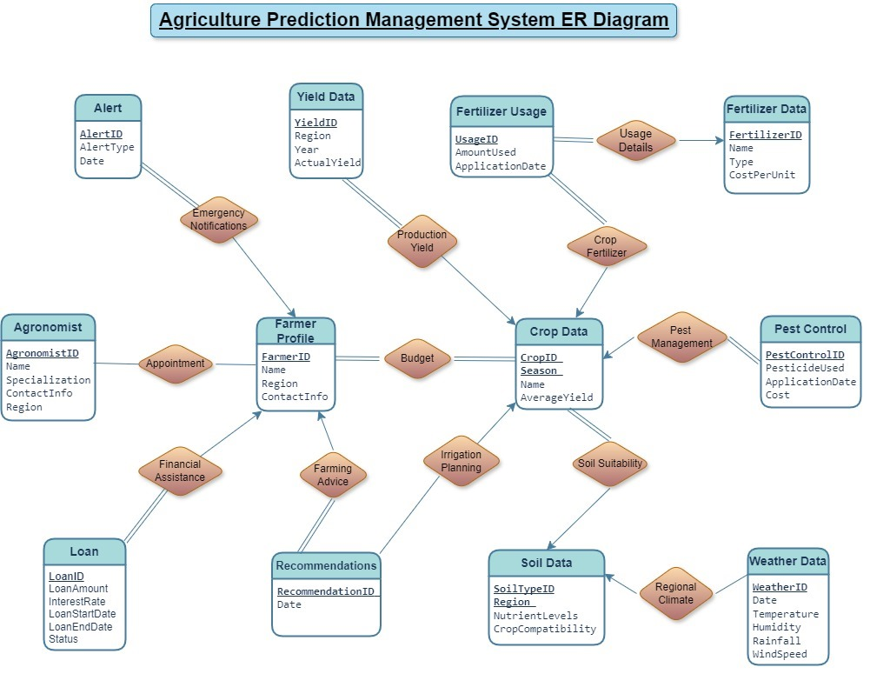

**9.Schema Diagram**

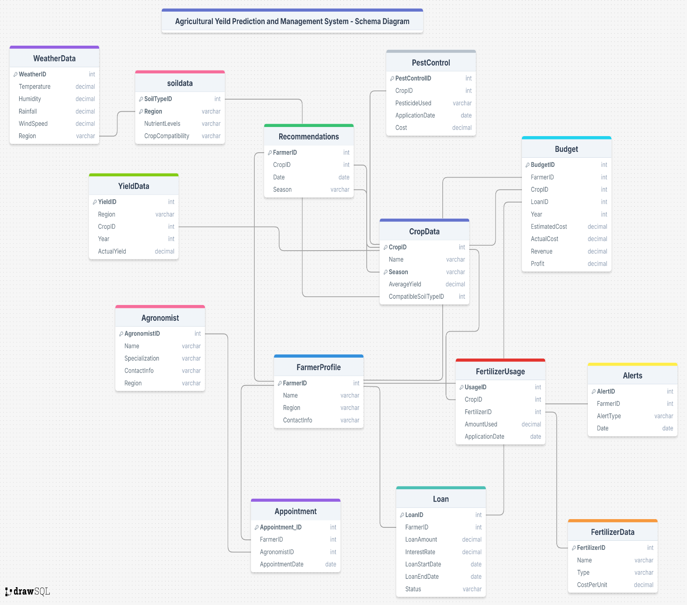

**10.Queries**

**11.CEP mapping**

* **How Knowledge Profiles (K’s) are addressed through the project and mapping among**

**K’s, COs and POs :**

|  |  |  |  |  |
| --- | --- | --- | --- | --- |
| **K’s** | **Attributes** | **How K’s are addressed though our project** | **CO** | **PO** |
| **K2** | **Mathematics** |  |  |  |
| **K3** | **Engineering**  **Fundamentals** | Our project involves a systematic formulation of  engineering fundamentals like programming  code, designing & problem solving .  **{demo,write like this}** | CO1,  CO2,  CO5  {demo} | PO1 |
| **K4** | **Specialist**  **Knowledge** | Because our project is related to import &  export we needed special knowledge of  economics like trade, tax & business operation. |  |  |
| **K5** | **Engineering**  **Design** |  |  |  |
| **K6** | **Engineering**  **Practice** |  |  |  |
| **K7** | **Comprehension** |  |  |  |
| **K8** | **Research**  **Literature** |  |  |  |

* **How Complex Engineering problem solving (P’s) are addressed through the project and**

**mapping among P’s, COs and POs :**

|  |  |  |  |  |
| --- | --- | --- | --- | --- |
| **P’s** | **Attributes** | **How P’s are addressed though our project** | **CO** | **PO** |
| **P1** | Depth of  knowledge  required | The project requires us to study one of the  fundamentals of engineering which is  Database Management System design (K3). It  also requires designing ER & Schema  Diagram(K5) and implementing the designs  (K6). |  |  |
| **P3** | Depth of analysis  required |  |  |  |
| **P4** | Familiarity of  issues |  |  |  |
| **P6** | Extent of  stakeholder  involvement and  conflicting  requirements |  |  |  |
| **P7** | Interdependence |  |  |  |

* **How Complex Engineering Activities (A’s) are addressed through the project and**

**mapping among A’s, COs and POs :**

|  |  |  |  |  |
| --- | --- | --- | --- | --- |
| **A’s** | **Attributes** | **How A’s are addressed though our project** | **CO** | **PO** |
| **A1** | Range of  resources |  |  |  |
| **A2** | Level of  interaction |  |  |  |
| **A3** | Innovation |  |  |  |
| **A4** | Consequences  for the society  & the  environment |  |  |  |
| **A5** | Familiarity |  |  |  |